**DAILY ONLINE ACTIVITIES SUMMARY**

|  |  |  |  |  |  |  |  |  |
| --- | --- | --- | --- | --- | --- | --- | --- | --- |
| **Date:** | **03/06/2020** | | | | | **Name:** | **PRANEETA P HANDRAL** | |
| **Sem & Sec** | **4​th​ SEM. & ‘B’ SEC.** | | | | | **USN:** | **4AL19CS401** | |
| **Online Test Summary** | | | | | | | | |
| **Subject** | | **OBJECT ORIENTED CONCEPTS** | | | | | | |
| **Max. Marks** | | **30** | | **Score** | | | **14** | |
| **Certification Course Summary** | | | | | | | | |
| **Course** | **Python for Machine Learning** | | | | | | | |
| **Certificate Provider** | | | **Greatlearning academy** | | **Duration** | | | **5 Hrs.** |
| **Coding Challenges** | | | | | | | | |
| **Problem Statement:** **Write a Java program to find Last Digit of a^b (a to the power b) for Large Numbers**  **Problem Statement:** **Write a function that takes a two-digit number and determines if it's the largest of two possible digit swaps.** | | | | | | | | |
| **Status:** **Executed.** | | | | | | | | |
| **Uploaded the report in Github** | | | | | **Yes** | | | |
| **If yes Repository name** | | | | | **LockdownCoding** | | | |
| **Uploaded the report in slack** | | | | | **Yes** | | | |

**Online Test Summary:​** 18CS45 online test was scheduled from 9:15 am t0 10:00 am .The portion for the IA was 2ND AND 3RD module, the questions were MCQ type.

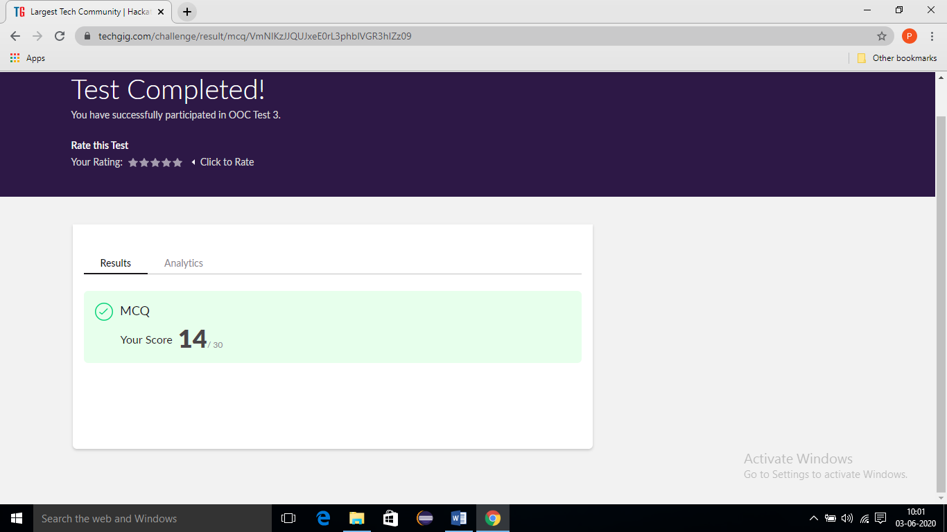

**Online Certification course Summary​:** **Today I have learn about some other Pandas User Defined Function and also execute the some of the basic function programs**

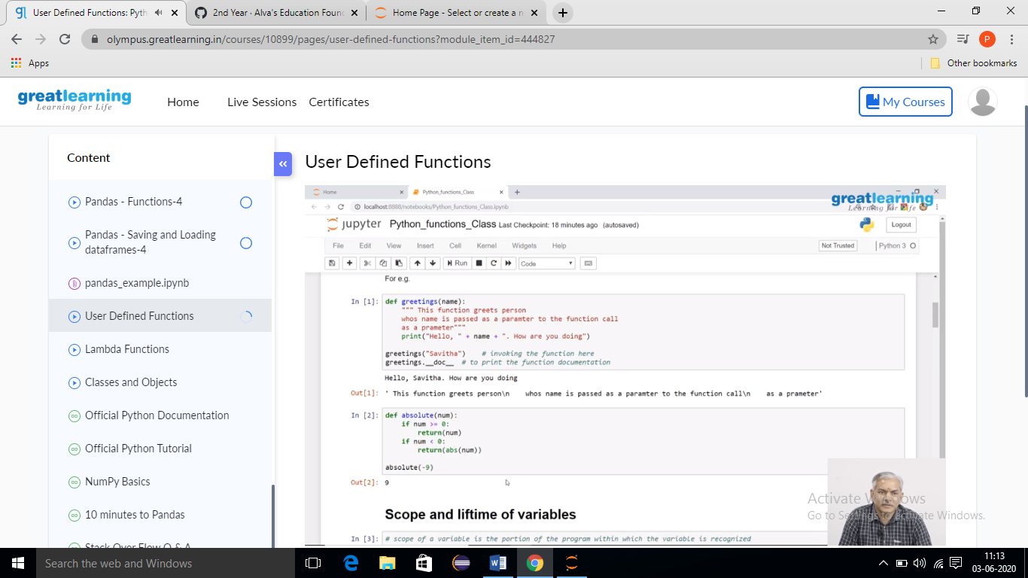

**Online Coding Summary​:** **Today I received the first program from prof.Venkatesh CSE Dept, second program was given by prof.shilpa GM CSE Dept**, **The program is mentioned above. to my GitHub repository and I’ve shared the snapshot below.**

